 APIIT Sri Lanka - Home | Facebook

**ASSIGNMENT**

**LEVEL 4**

**COMP40004 : Web Development & Operating Systems 1 Individual Assessment**

**Batch Code: COM24A1**

**Name: Dahamdi Balamurale**

**CB Number: CB016223**

**INSTRUCTION TO CANDIDATES**

1. **Late submission will be awarded zero (0) unless extenuating circumstances (EC) are upheld.**
2. **Cases of plagiarism will be penalized.**
3. **The assignment should be submitted as softcopy via LMS**
4. **All evidences related to the sprint implementation in group assignment must be show cased in the final documentation.**
5. **Activity Diagrams**
6. **Save to Favorites**

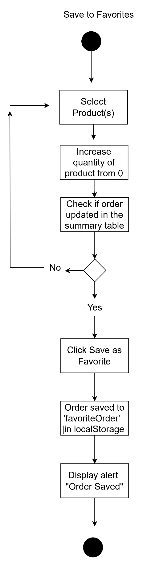

1. **Apply Favorites**

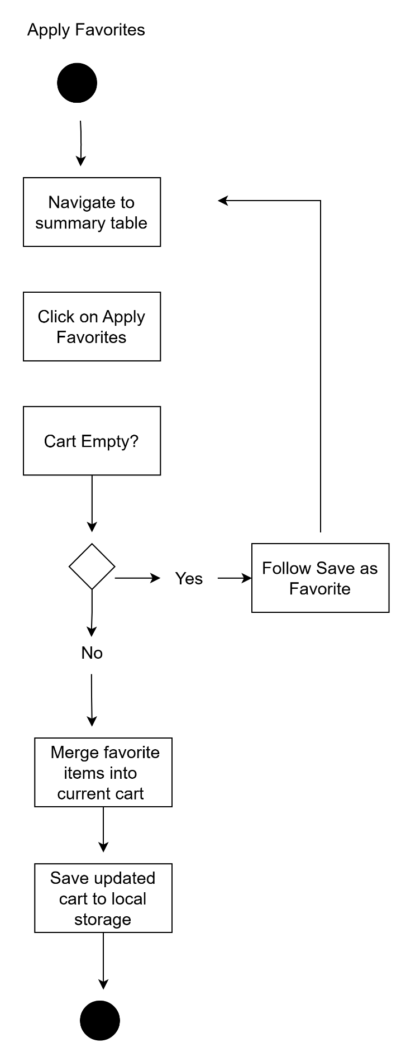

1. Buy Now

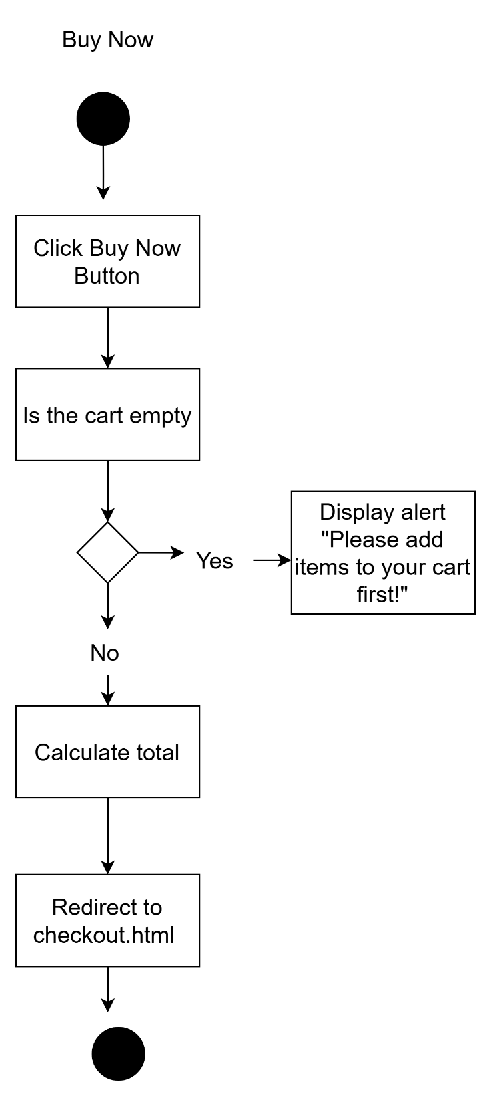

1. Checkout Page

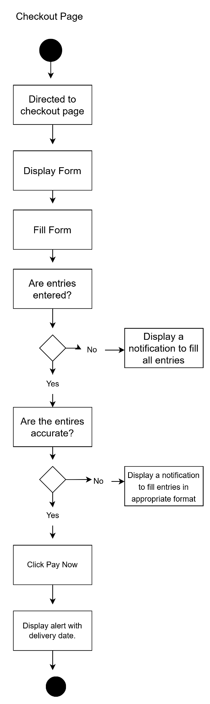

1. **Lighthouse Testing**
2. **Order Page: index.html**

**Mobile View**

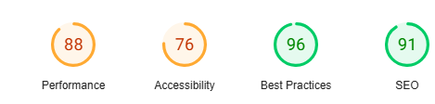

**Desktop View**

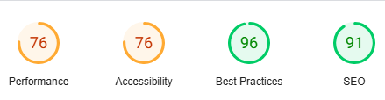

1. **Checkout Page**

**Desktop View**

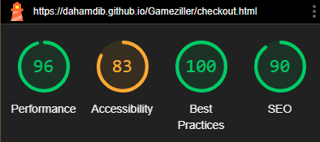

**Mobile View**

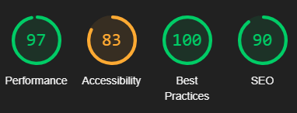

1. **Wave Testing**

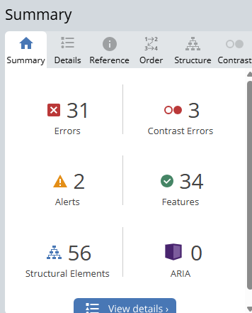

1. **HTML Validity Checker**

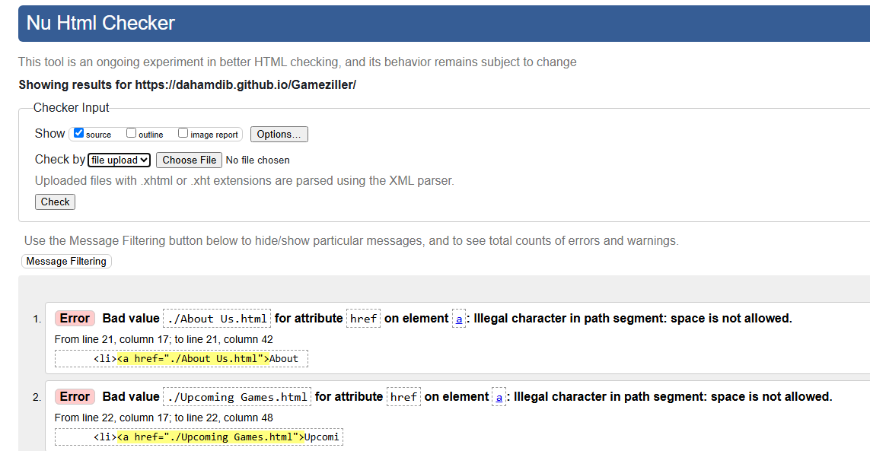

1. **CSS Validity Checker**

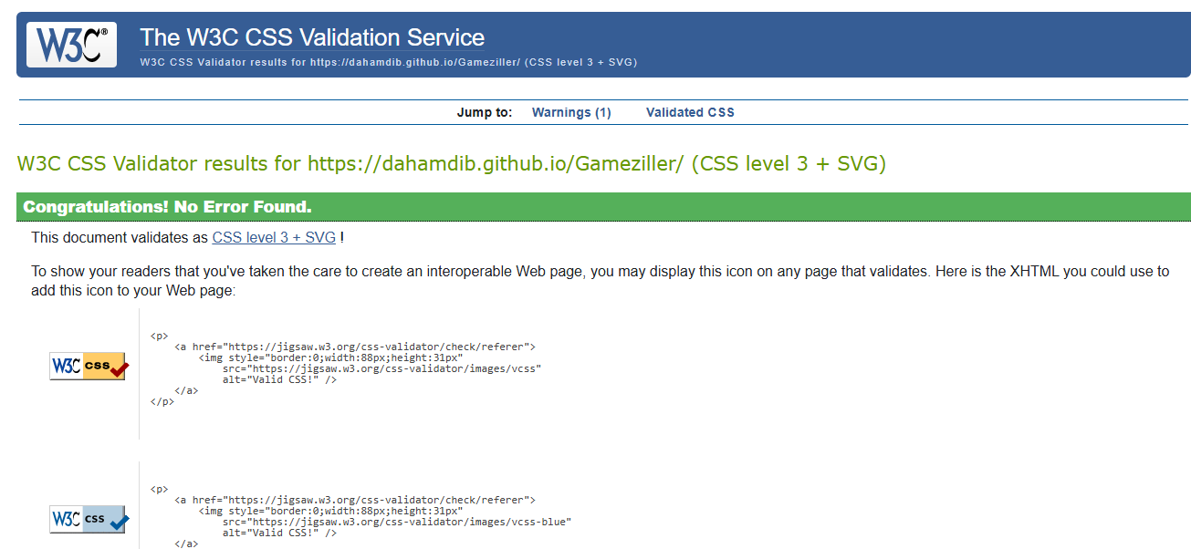

1. **Test Cases Table**

|  |  |  |  |  |
| --- | --- | --- | --- | --- |
| **Test Case** | **Feature** | **Action** | **Expected Result** | **Pass/Fail** |
| **1.** | **Save to Favorites** | **Click “Save as Favorite”** | **Items on order summary gets saved in local storage.** | **Pass** |
| **2.** | **Apply Favorites** | **Click Apply Favorites** | **Items previously saved appear on order summary** | **Pass** |
| **3.** | **Buy Now** | **Click "Buy Now"** | **Goes to checkout page** | **Pass** |
| **4.** | **Buy Now (Empty)** | **Click "Buy Now" with empty cart** | **Shows alert , no redirect** | **Pass** |
| **5.** | **Checkout Submit** | **Click “Pay Now”** | **Submit filled form** | **Pass** |
| **6.** | **Checkout Submit (Invalid information)** | **Click ”Pay Now”** | **Notification to enter valid data** | **Pass** |